Handling dropdown box:
Let us first see how to handle a dropdown box.
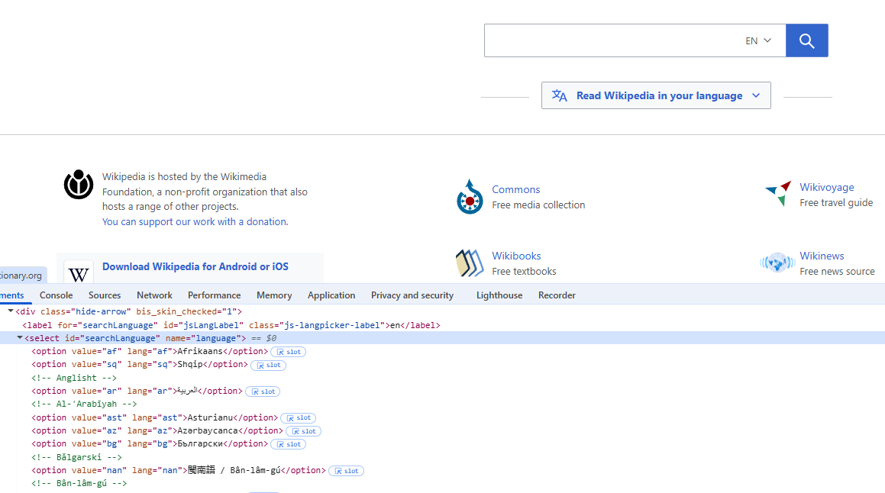
We can select element from dropdown box using 3 ways:
- Label
- Value
- Index
Within the select tag all the options are in the option tag. We can select all the options by applying all functions on the option tag.
Using innerText function we extract the text of the element and using getAttribute we fetch value corresponding to an attribute.
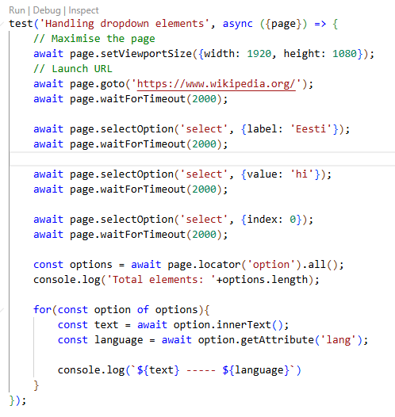
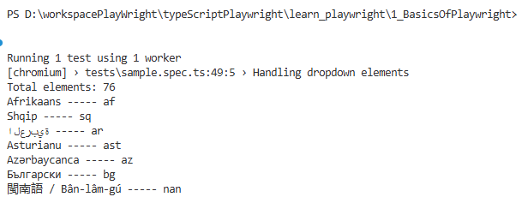

Handling links:
All the links are in the anchor (a) tag.
Using nth we can identify a single element from the list by passing the index.
In the footerNavBlock we have identified the footer elements. We can narrow down the search by passing indexes.
